Arizona Department
of Health Services
Bureau of Emergency Medical Services and Trauma System

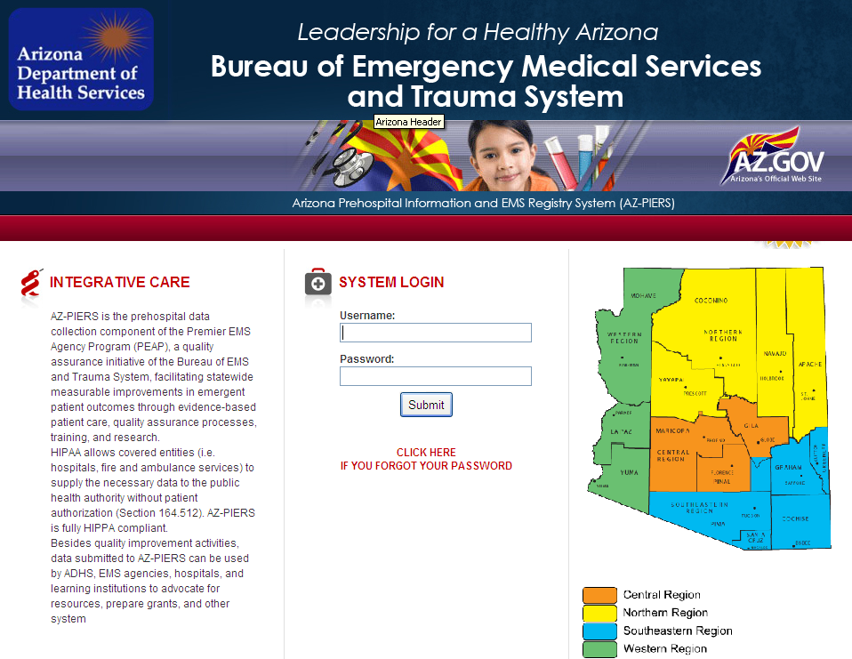
Arizona Pre-Hospital Information and EMS Registry Program
(AZ-PIERS)
Combined Application Packet
September 2012
Table of Contents

September 2012
ARIZONA DEPARTMENT OF HEALTH SERVICES/BUREAU OF EMS AND TRAUMA SYSTEM
ARIZONA PREHOSPITAL INFORMATION & EMS REGISTRY SYSTEM (AZ-PIERS)

PART I. Description of AZ-PIERS

AZ-PIERS is Arizona’s FREE pre-hospital data registry that gives its EMS agencies the ability to generate and transmit electronic Patient Care Records (ePCRs) at the scene, in the hospital or at the station. Internet connection IS NOT required. Hospitals can use Dashboard to accept ePCRS generated by the EMS agencies. AZ-PIERS uses ImageTrend’s FieldBridge, StateBridge, and Hospital Dashboard applications. AZ-PIERS is National EMS Information System (NEMSIS) Version 2.2.1 Gold Compliant and accepts any other programs meeting this criteria.

I. Benefits of AZ-PIERS:
A. EMS Agency Benefits:
- Free NEMSIS 2.2.1 Gold Compliant ePCR software.
- Report Writer 2.0 (ImageTrend) to generate customized and/or standard reports.
- ePCR data for quality assurance (QA), training, tracking, grant writing, administrative reports, CEU tracking, and contracts.
- Any EMS agency with NEMSIS compliant ePCR software can also submit to AZ-PIERS.
B. Hospital Benefits:
- Hospitals have access to Dashboard in order to receive ePCRs transmitted by EMS crews in the field.
- Improved access to completed EMS runs reports.
- Base Hospitals will be able to use ePCR data for QA, training activities, and CEU tracking.
- Hospitals will be able to respond to grants for funding support.
C. State of Arizona Benefits:
- Provide every agency with standard performance improvement reports.
- Respond to EMS and trauma system statutory committees queries.
- Develop reports to assist EMS regions, base hospitals and medical directors.
- Provide aggregate de-identified data to support funding justifications for programs internal and external to ADHS.

II. Eligibility for participation:
All Arizona EMS agencies (private, public, and tribal) can participate in AZ-PIERS by contacting the Bureau of EMS and Trauma System (BEMST) to request an application. Once an application is processed the EMS agency will receive a User ID and Password, along with instructions for downloading the Field Bridge Software onto as many laptops/PCs the EMS agency needs. All costs for technical support are funded by the Arizona Department of Health Services.
Participating EMS agencies also receive Report Writer 2.0, the ImageTrend software that generates customized and standard reports for Quality Improvement (QA), training, tracking, grant writing, administrative reports, contracts/applications, and other purposes. Additional Modules (e.g., a Billing module) can be purchased from ImageTrend at the State Contract pricing.
The AZ-PIERS StateBridge URL is: https://azemsis.azdhs.gov. This is the login homepage for EMS agencies to electronically submit their EMS data to the AZ-PIERS secure server.
EMS agencies already using NEMSIS Version 2.2.1 Gold Compliant ePCR software can still participate in AZ-PIERS by having their software vendor obtain an Automated Programming Interface (API) with ImageTrend.
Please contact Anne Vossbrink, MS, EMS & Trauma Data Manager at (602) 364-3164 or Anne.Vossbrink@azdhs.gov for additional information on AZ-PIERS, a FieldBridge Demo, and Hospital Dashboard.
III. Application Process:
All EMS agencies and hospitals can fax or email their respective application found at the end of the form to Anne Vossbrink at (602) 364-3568 or Anne.Vossbrink@azdhs.gov.

AZ-PIERS Application Packet, Sept 2012

Page 1

ARIZONA DEPARTMENT OF HEALTH SERVICES/BUREAU OF EMS AND TRAUMA SYSTEM
ARIZONA PREHOSPITAL INFORMATION & EMS REGISTRY SYSTEM (AZ-PIERS)

PART II. AZ-PIERS EMS Application Process

EMS Agencies Application Process

Procedure:

- EMS agencies who wish to use the AZ-PIERS ePCR software will complete the AZ-PIERS EMS Agency Application (Part III).
- The Bureau will review and process the completed application to create an AZ-PIERS Access Account for the EMS Coordinator.
- The Bureau will work with ImageTrend to issue a FieldBridge/Service Bridge User License to the Agency. ImageTrend will email the EMS coordinator Installation Instructors and a User Agreement.
- The EMS coordinator will read through the documents and follow the necessary procedures.
- The EMS coordinator can expect to receive their User ID and Password through email along with a link to the AZ-PIERS URL Address. This email will also contain instructions to log in and retrieve User Manuals.
An in-person or over the phone training session may additionally be provided.
Who Should Complete the AZ-PIERS Participating EMS Agency Application?
AZ-PIERS should be completed by the EMS Division Chief, QA Coordinator, or other individual who oversees the Patient Care Records (PCR). Care should be taken to validate PCRs generated by the personnel, performing QA checks, and protect health information accordingly to HIPAA and other laws and policies.

Field Bridge 5.3 System Requirements
Required: | Recommended: | Optimal:
500 MHz Processor | 1 GHz Processor | 1.5 GHz Processor
512 MB RAM | 2 GB RAM | 4 GB RAM
200 MB Available Hard Disk Space | 600 MB Available Hard Disk Space | 1 GB Available Hard Disk Space
 | 802.11 wireless | 802.11 wireless
 |  | Bluetooth
 |  | GPRS/CDMA cellular modem

Submitting the Completed AZ-PIERS Participating EMS Agency Application
Please email the completed AZ-PIERS EMS Agency Application as an attachment to Anne Vossbrink at Anne.Vossbrink@azdhs.gov. If necessary, the Application can be faxed to 602-364-3568 Attn: Anne Vossbrink.

AZ-PIERS Application Packet, Sept 2012
Page 2
Page 2
AZ-PIERS Application Packet, Sept 2012
AZ-PIERS Application Packet, Sept 2012
Page 2
ARIZONA DEPARTMENT OF HEALTH SERVICES/BUREAU OF EMS AND TRAUMA SYSTEM
ARIZONA PREHOSPITAL INFORMATION & EMS REGISTRY SYSTEM (AZ-PIERS)

Part III. AZ-PIERS EMS Agency Application

Office Use Only _______________________
EMS Agency Information
EMS Agency Name: |  |  |  |  | Annual Run Volume:
Certificate of Need #:  Coverage Area (sq.miles): |  |  |  |  | Parent Company:
Street Address: |  |  |  |  | Zip Code:
City: |  |  | County: |  | State:
Station Location (if differs from above):
Base Hospital: |  |  |  | Base Hospital Contact Name:  Email or Phone:
Other Stations:
EMS Coordinator Information
First Name: |  | Last Name: |  |  |  |  | Middle Initial:
Best Method of Contact:  Best Time to Contact: |  | Email: |  |  |  |  | Phone:
Other (fax/mail):
Primary Type of Service (check all the apply)
ALS | BLS |  | Specialty | Critical Care |  | Air |  | Medical Transport  Inter-facility
Additional Information
Do you currently have ePCR system? | Yes  No |  | Name of ePCR: |  |  | Additional Info:
Daylights Savings Time? | Yes  No |  | Interest in finding out about e-billing?  (cost uncovered by state) | Yes  No

Page 3
AZ-PIERS Application Packet, Sept 2012
Page 5
Page 5

Arizona Department
of Health Services
Bureau of Emergency Medical Services and Trauma System
ARIZONA DEPARTMENT OF HEALTH SERVICES/BUREAU OF EMS AND TRAUMA SYSTEM
ARIZONA PREHOSPITAL INFORMATION & EMS REGISTRY SYSTEM (AZ-PIERS)

PART IV. AZ-PIERS HOSPITAL APPLICATION PROCESS

Hospitals Application Process

Procedure:

- Arizona hospitals who wish to use the Hospital Dashboard will complete the AZ-PIERS Hospital Application (Part III).
- The Bureau will review and process the completed application to create an AZ-PIERS Access Account for the Pre-hospital Coordinator.
- The Bureau will work with ImageTrend to issue a Dashboard License to the Agency.
- The Pre-hospital coordinator will read through any follow up documents and follow the necessary procedures.
- The Pre-hospital coordinator can expect to receive their User ID and Password through email along with a link to the AZ-PIERS URL Address. This email will also contain instructions to log in and retrieve User Manuals.
Who Should Complete the AZ-PIERS Hospital Application
The hospital application should be filled out by the Pre-hospital Coordinator for the Hospital’s Emergency Department or other individual who oversees the medical direction of EMS. These duties include, but are not limited to, validating patient care records (PCRs) generated by the EMS agency’s personnel, performing quality assurance checks on protocols, treatment, documentation, etc., ensuring protected health information (PHI) is secure and that applicable HIPAA and other confidentiality laws and policies are enforced.

Field Bridge 5.3 System Requirements
Required: | Recommended: | Optimal:
500 MHz Processor | 1 GHz Processor | 1.5 GHz Processor
512 MB RAM | 2 GB RAM | 4 GB RAM
200 MB Available Hard Disk Space | 600 MB Available Hard Disk Space | 1 GB Available Hard Disk Space
 | 802.11 wireless | 802.11 wireless
 |  | Bluetooth
 |  | GPRS/CDMA cellular modem

Submitting Completed the AZ-PIERS Hospital Application
Please email the completed AZ-PIERS hospital application as an attachment to Anne Vossbrink at Anne.Vossbrink@azdhs.gov, or fax it to 602-364-3568 Attn: Anne Vossbrink.

Page 4
AZ-PIERS Application Packet, Sept 2012

Page 5
Page 5

ARIZONA DEPARTMENT OF HEALTH SERVICES/BUREAU OF EMS AND TRAUMA SYSTEM
ARIZONA PREHOSPITAL INFORMATION & EMS REGISTRY SYSTEM (AZ-PIERS)

Part V. AZ-PIERS Hospital Application

Office Use Only _______________________
Hospital Information
Hospital Name:
Street Address: |  |  |  |  |  | Zip Code:
City: |  | County: |  |  |  | State:
Parent Company/Affiliates:
Pre-Hospital Coordinator/Manager Information
First Name: |  |  | Last Name: |  |  |  |  |  | Middle Initial:
Best Method of Contact:  Best Time to Contact: |  |  | Email: |  |  |  |  |  | Phone:
Other (fax/mail):
Affiliated EMS Agencies
Name (s): |  |  |  |  | Email or phone:
Agencies for which you base:
Additional Information
Current ePCR system? | Yes  No | Name of ePCR: |  |  |  |  | Additional Info:
Daylights Savings Time? | Yes  No | Participation in AZ Trauma Database |  | Yes Full  No Reduced

Page 5
AZ-PIERS Application Packet, Sept 2012

